How Did We Get Here? – The Hebraic-Christian Worldview in Comparison with Others
Biblical | Theological | Historical | Philosophical | Practical | Example

The prof told the student, “Education is about growth, reconsideration of beliefs” What she meant was…
I spoke with my classmate afterwards suggesting that what the professor was suggesting was not necessarily “growth,” but something more like “regression.” Behind what is called a “progressive” mindset is that progress accepts all cultural changes. But to the progressive person, “progress” is only ever in one direction; change away from a fixed, permanent, absolute, boundaried view of the world.

Some will say, “The world is worse now than it ever was.” I have to say that kind of comment is a slap in the face to all who have been martyred for the sake of Christ.

Our current time & place must be seen within a wholistic view of human history. A great overview of the historical progression of worldview thinking is to stream How Shall We Then Live by Francis Schaeffer [free on YouTube via Vision Video https://www.youtube.com/watch?v=5QeOrzGbLkU]

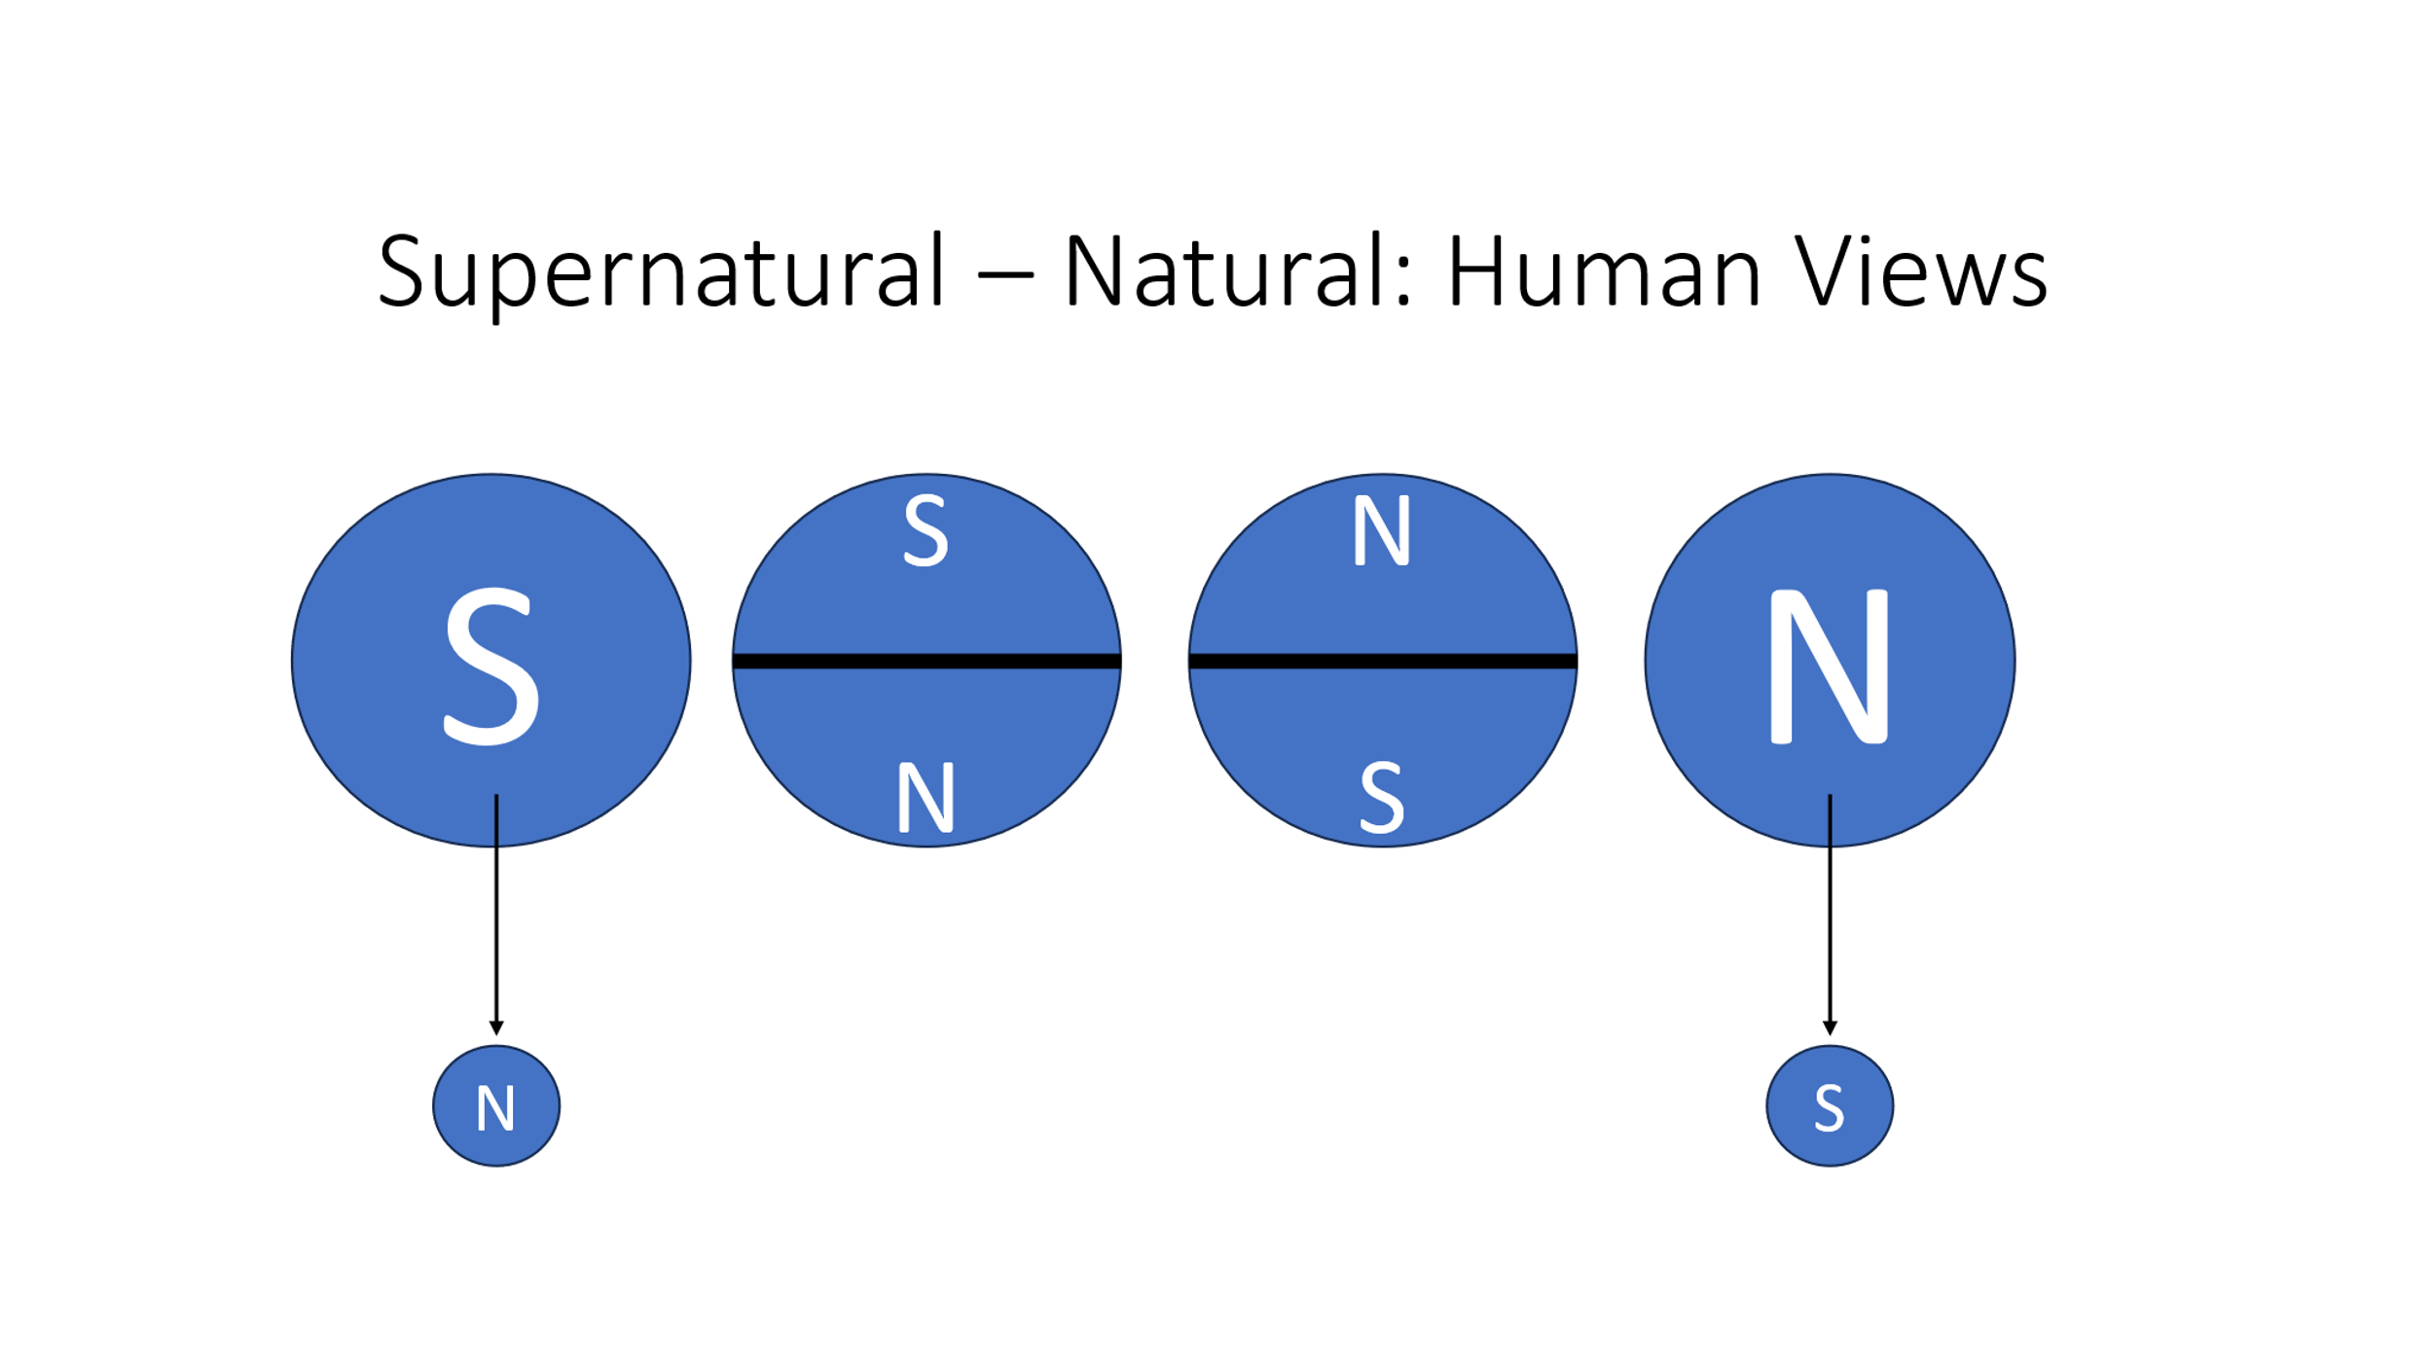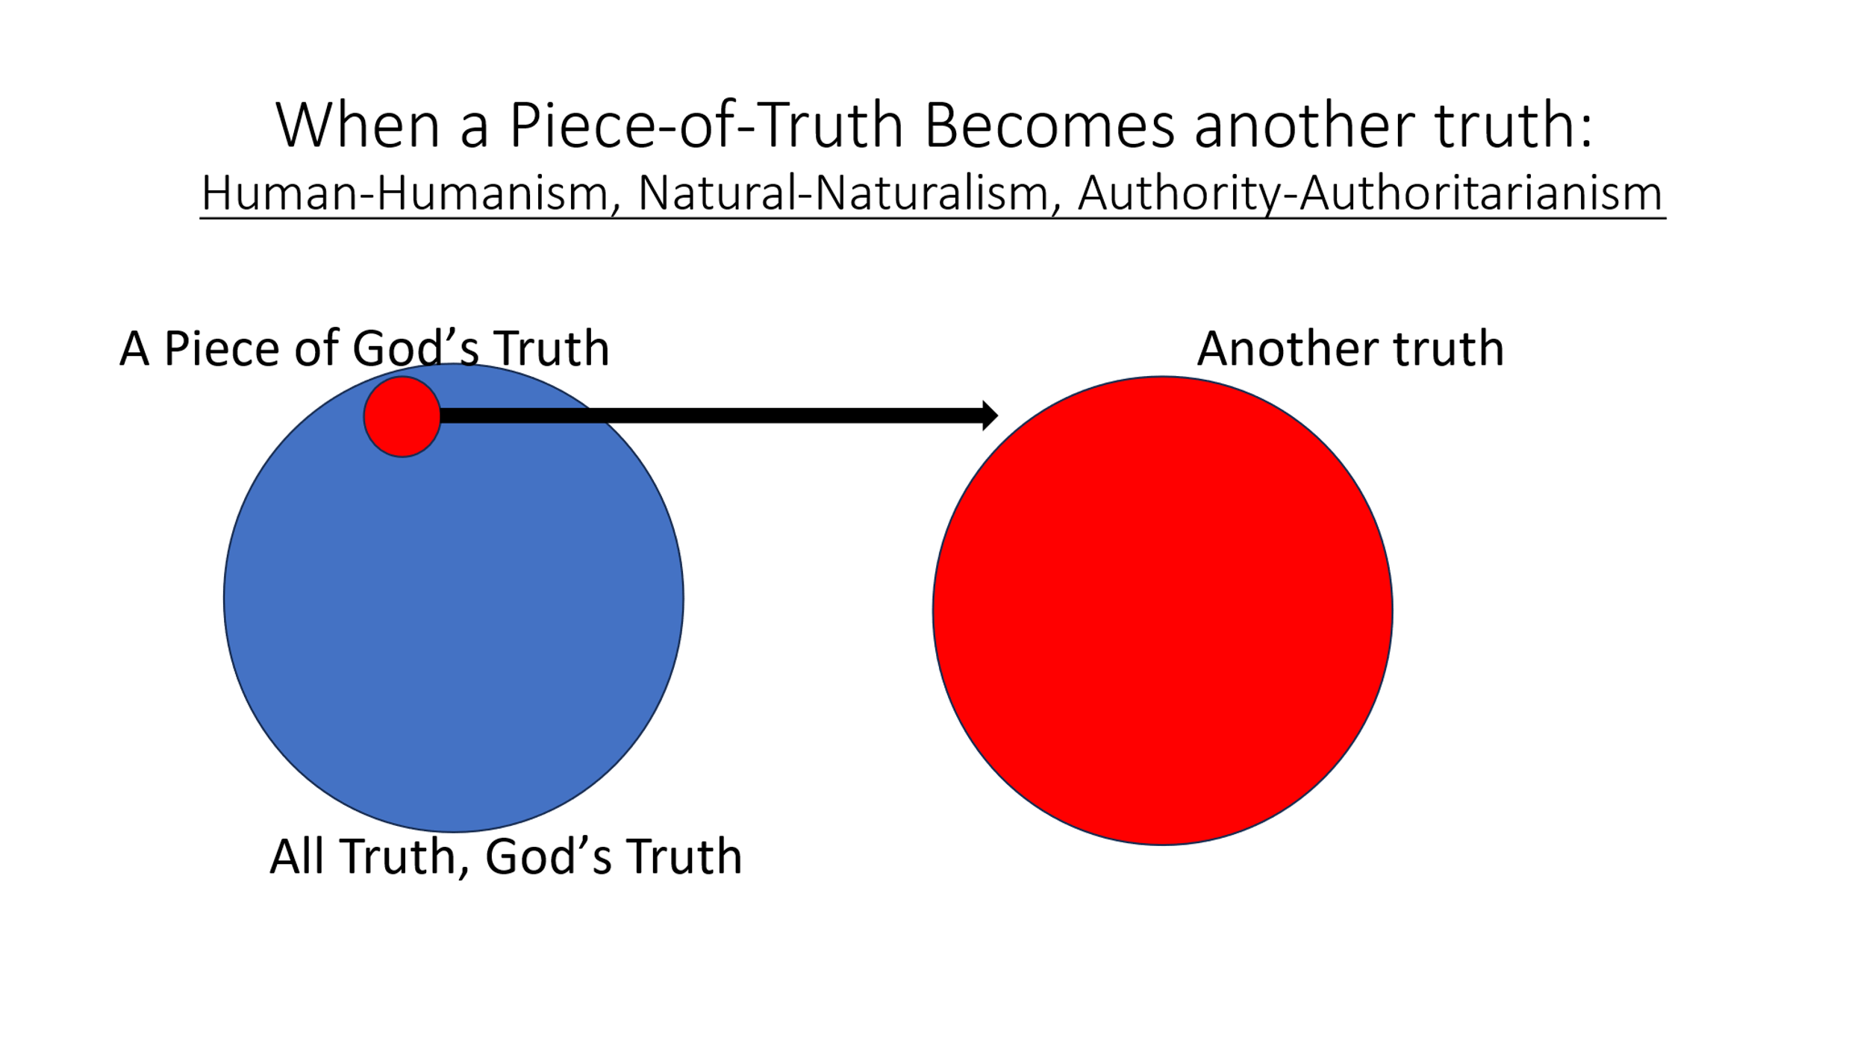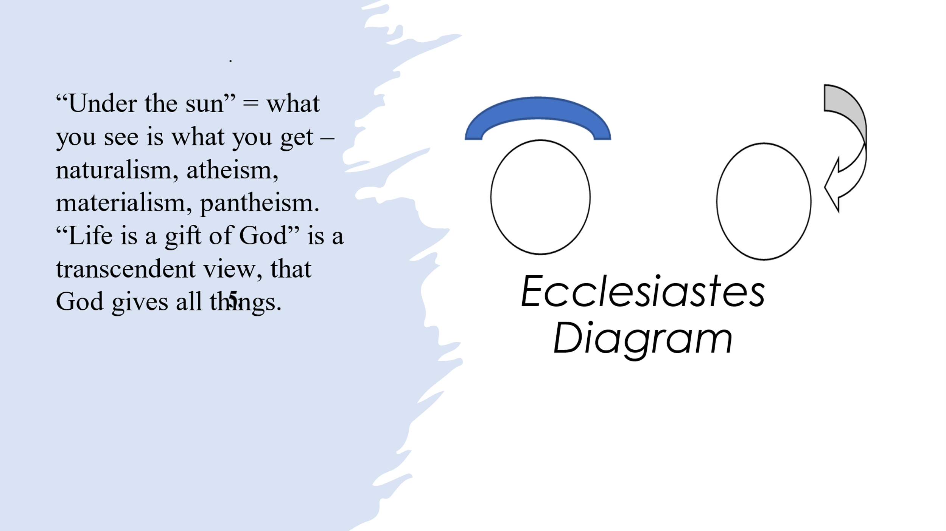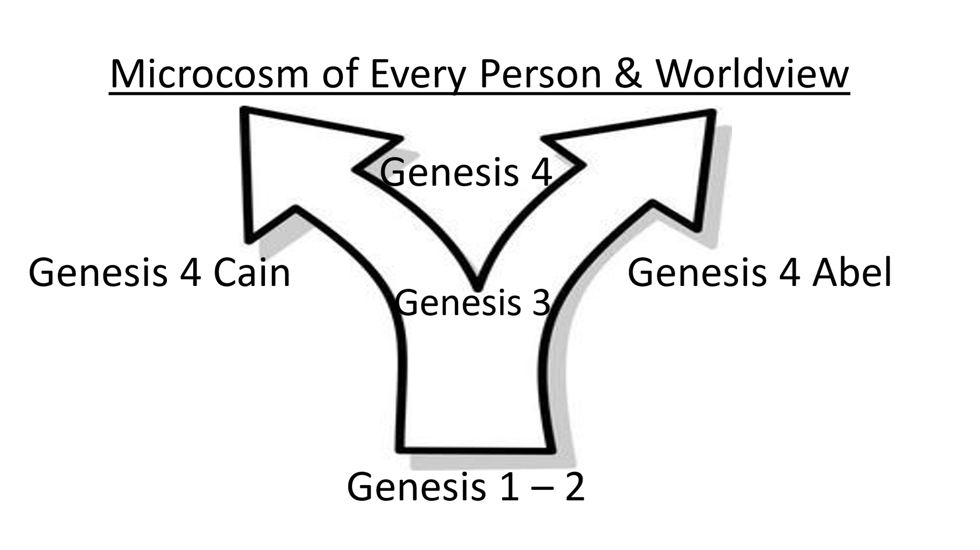

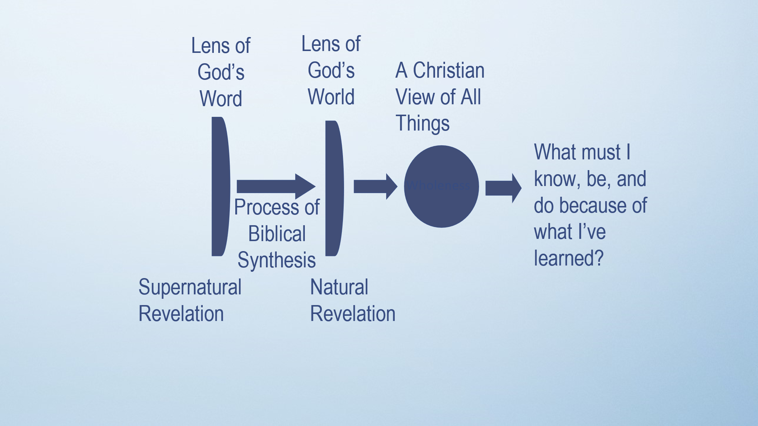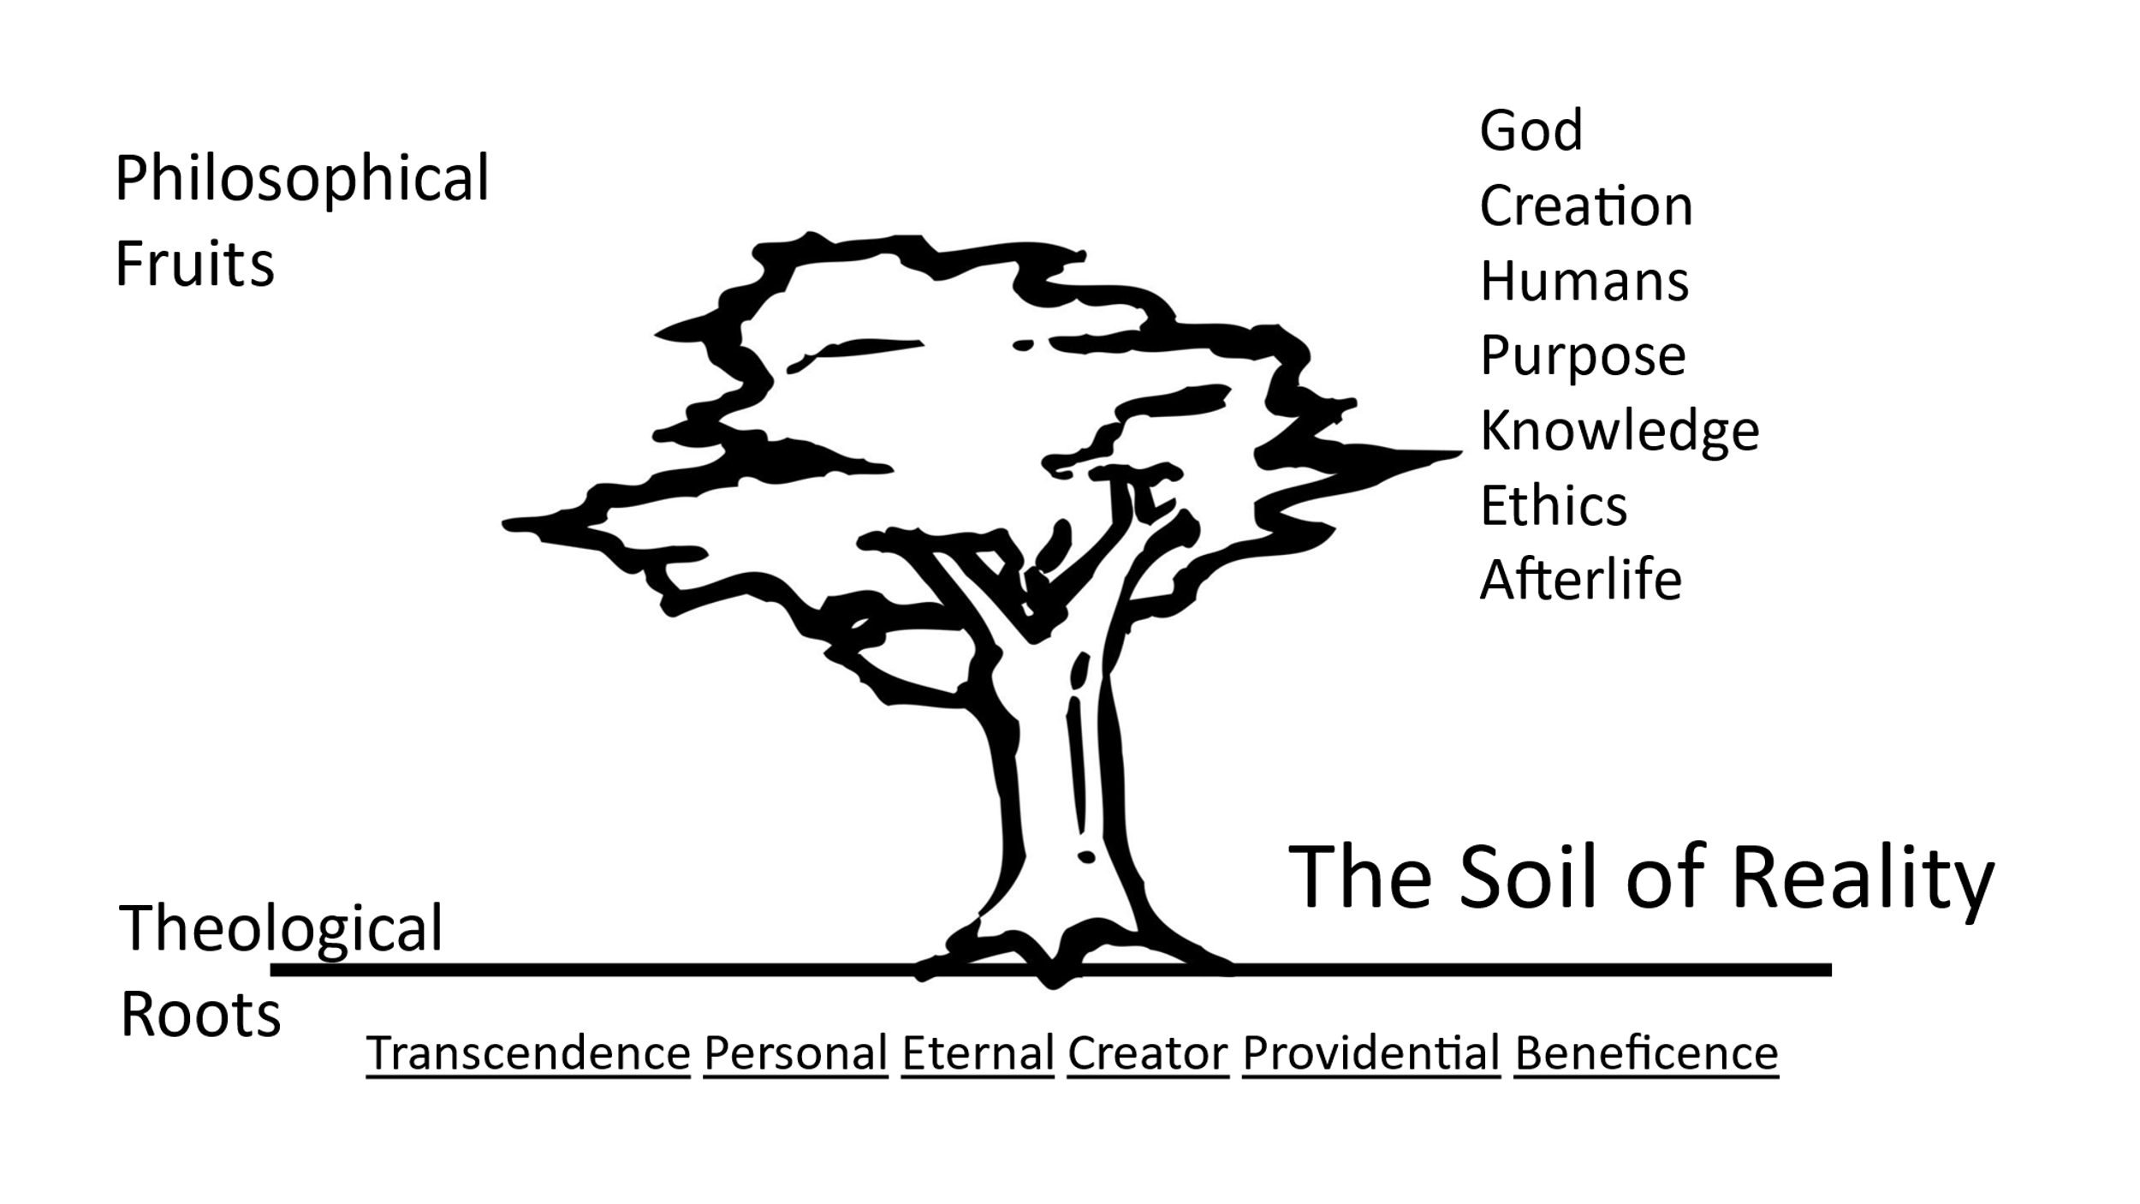

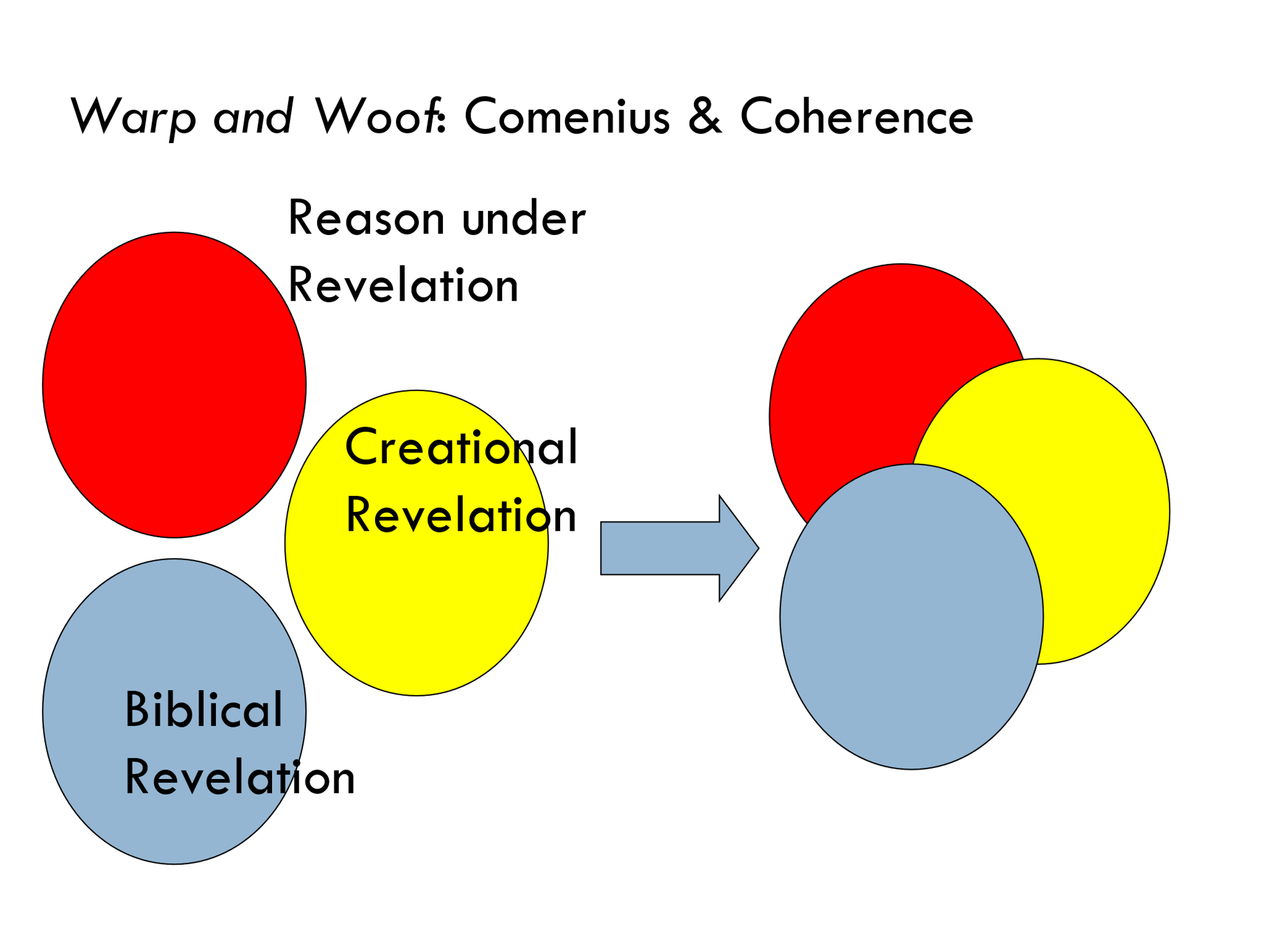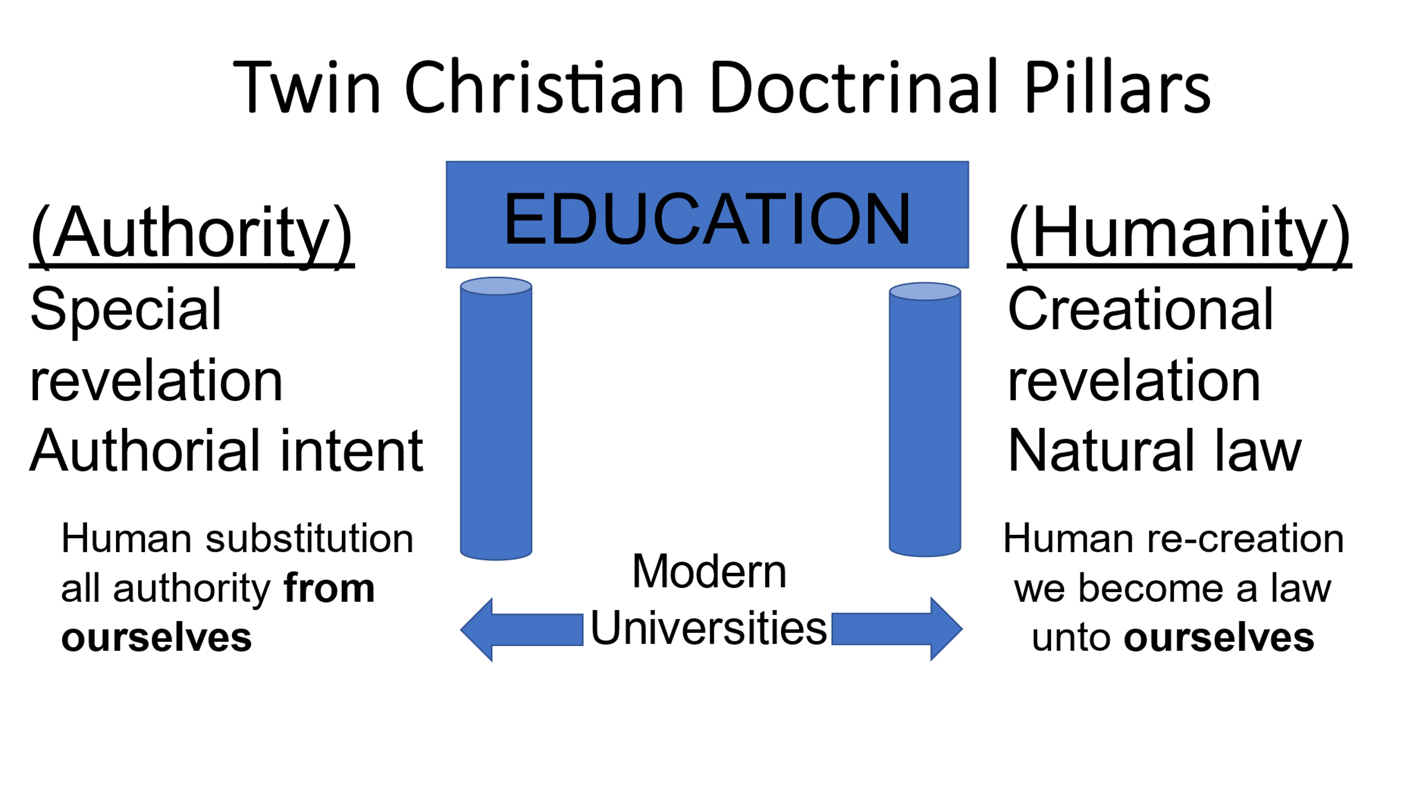

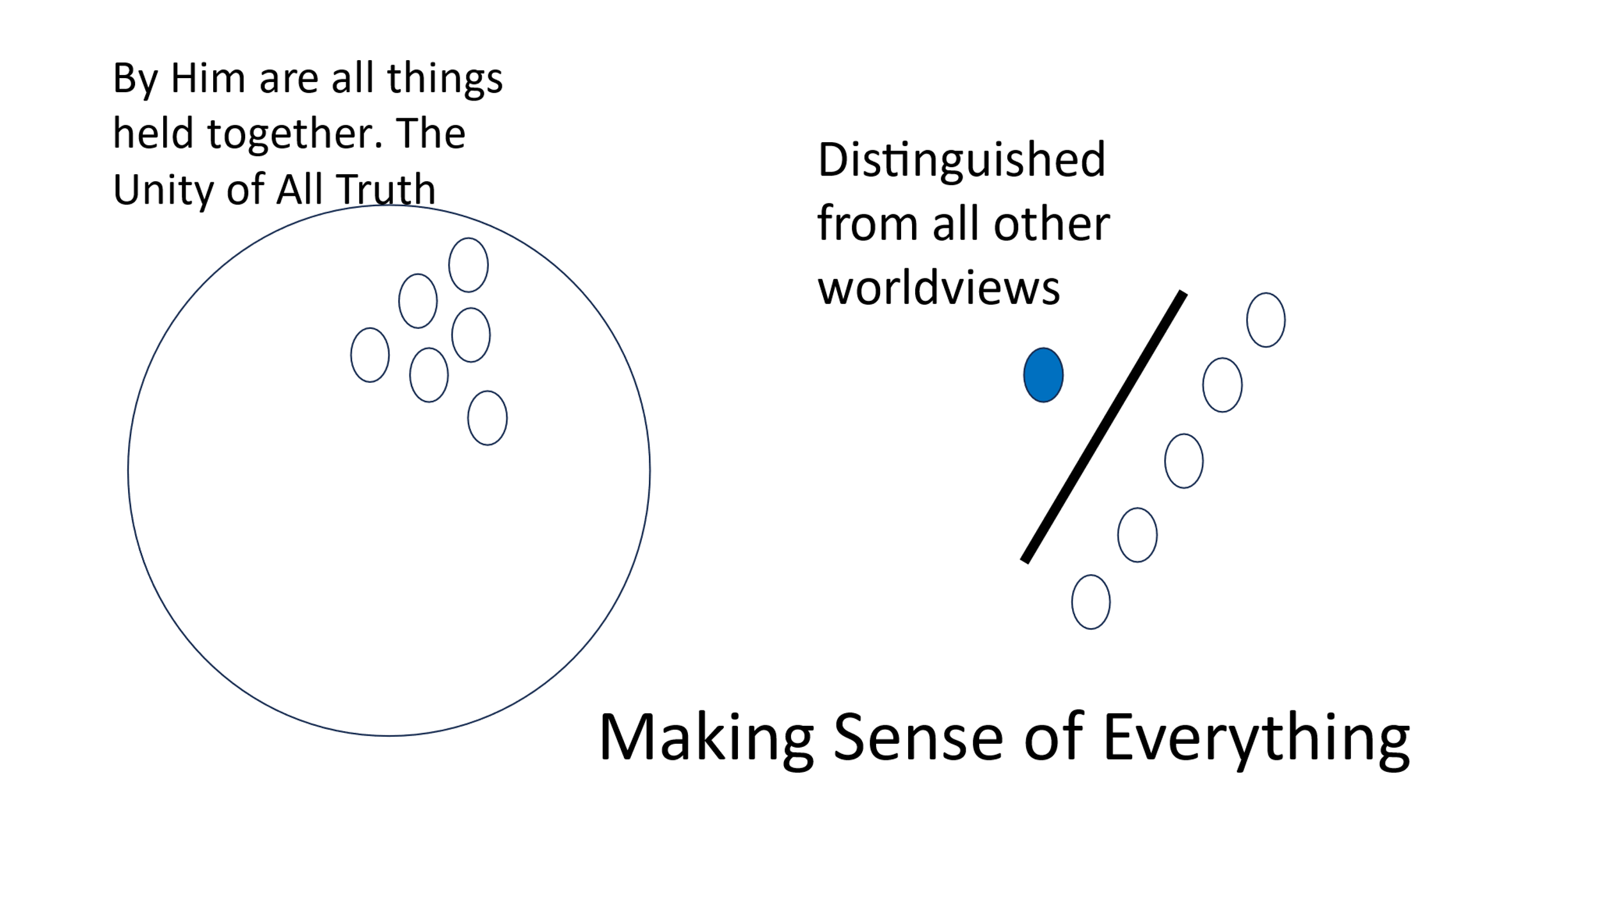

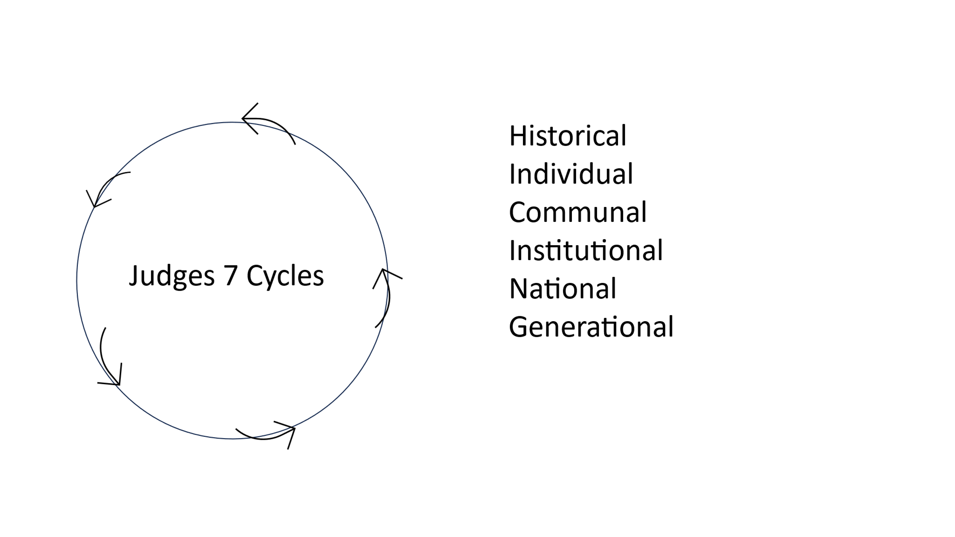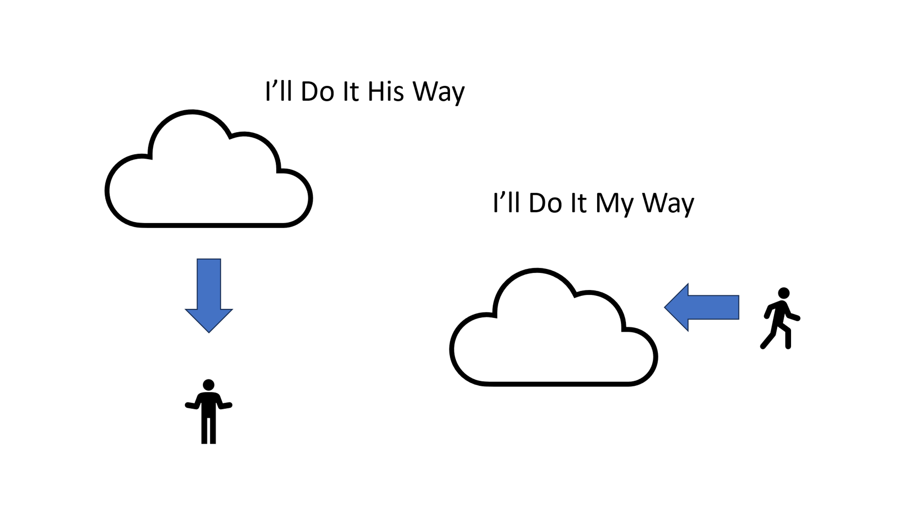

Historical Repetition: Individual – Communal – Institutional – National – Generational
“How Did We Get Here?” to “Where Do We Go From Here?”
1. Everyone believes something (Deut 4, Romans 16.25-27)
2. Respect others with different viewpoints (2 Tim 2.24-26, 1 Pet 3.15-16)
3. Know what & why you believe (2 Tim 2.15)
4. Solidify your worldview in Scripture (Rom 10.17, 15.4, 2 Tim 3.16-17)
5. “Encourage each other with sound doctrine” (“each other” = church community Titus 1.9)
6. Teach for the remnant (Isa 1.9, 6.13, 11.11, 17.6, 28.5, 37.31-32, 46.3)
7. Do good, do good, do good (Titus 2.14, 3.1, 8, 14)

