Vocation IS Ministry
Our abilities, whatever they may be, are God-given. Our work, no matter what we do,
matters to God. Our jobs, well done, show our love for others.
Episode Twelve: Work It Out
At the end of the day, employers want you to practice 1 Thessalonians 4:11-12 (not 2 Thess 3:6-12)
At the end of the day, employees want you to practice 1 Peter 5:1-5 (not 3 John 9-10)
Excellence & Benevolence (Prov 22:29; 27:23-27; Rom 13:9-10; 1 Thess 4:9-12)
My 3 Questions: (1) What do I want out of this course? (2) What am I willing to do to get what I want out of this course? (3) How will I allow the course to shape my knowing – being – doing?
“Before Outsiders” Col 4:5-6, 1 Thess 4:11-12, Titus 2:1-10, 3:2, 1 Peter 2:11-17, 3:11-17
“Good” = 9x in Titus; “Do good” (3x, 3:1, 8, 14); “Good” proceeds from the Good God who has given His grace for our salvation (2:11) training us to renounce ungodliness, to live self-controlled, upright, godly lives (12) to purify for Himself a people zealous for good works (14).

Motherhood – Homemaking, episode #1, College – “Why the University Should Matter to The Church,”
Trades – Shepherding, Farming, Have-to – Provide for Family, Gig-economy – job-juggling, Attitudes – Lazy vs. Diligent, Making-ends-meet, where “daily bread” and Providence meet
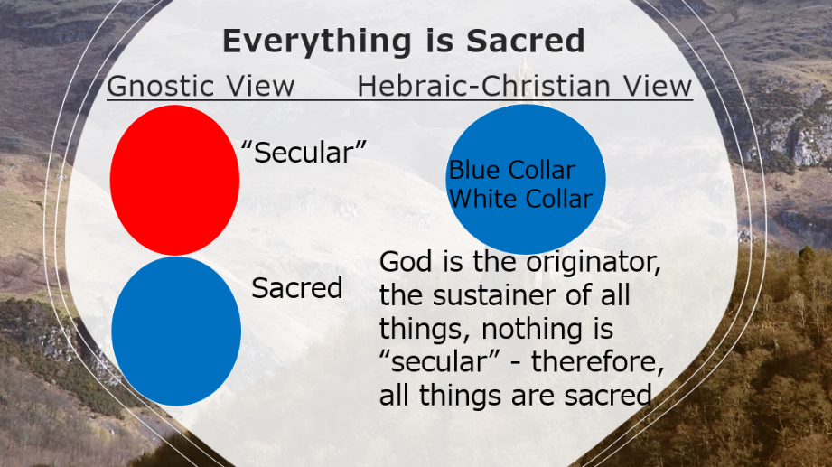
What We Already Know

Books / Articles Mentioned in Today’s Teaching
- Shop Class as Soulcraft: An Inquiry into the Value of Work Matthew B. Crawford
- The Dirty Life: A Memoir of Farming, Food, and Love Kristin Kimball
- Keeping House: The Litany of Everyday Life Margaret Kim Peterson
- The Myth of the Robber Barons: A New Look at the Rise of Big Business in America Burt Folsom
- Search for God & Guinness: A Biography of the Beer that Changed the World Stephen Mansfield
- “Why Businessmen Should Read Great Literature” Vigan Guroian
- Theology by the Pint, Theology on Tap
- “Thoughtful Christians in Culture,” video series, MarkEckel.com
- Cities of God: Christianity Became an Urban Movement that Conquered Rome Rodney Stark
- Kingdom Calling: Vocational Stewardship for the Common Good Amy L. Sherman
- The Gospel Comes with a Housekey Rosaria Butterfield

Questions
- As an employee, how do you do your work?
- As an employer, how to you treat your workers?
- As a person, how much do you give to your work?
- What can I read or watch to encourage my work?
- How can my work be a testimony?
1. In Genesis 2 alone, God works as: Craftsman 2:2 Artisan 2:7, 9 Gardener 2:8 Fashion Designer 2:18 Zoologist 2:19 Potter 2:19 Builder 2:22. We mirror God’s work.
2. God makes everything; He is distinct from humanity. Work given as a gift.
3. God’s reality for creation: the words for “create/make.” Our work replicates God’s work.
4. God stationed unseen principalities in place (Ps 33:9; 119:91; 148:6). Work for our benefit.
5. God gives invisible, unchanging rules, determined and established at creation, which run the universe at the Creator’s behest, all assigned properties and place (Jer 33:2, 20-21, 25-26; Lev 26:4; Jer 8:7; Gen 18:10, 14; Ecc 3.11). Work is good (Ecc 2:18-23 vs 2:24-26).
6. Repetition in chores, cleaning, memory work, maintenance, and drills suggest a regular, routine of life. Daily patterns produce results. This kind of work is often referred to as “menial,” “tedious,” or “boring.” These words are a result of perspective and attitude. We should view nothing as “below me,” small, or worthless. We should work hard now for tangible outcomes later (Prov 22:29; 27:18; 2 Tim 2:6).
7. Daily assignments and schedules suggest that we plan our work and work our plan. Concentrating on the tasks at hand is the goal of the worker. Strategy, intensity, and commitment are necessary ingredients to finish any assignment (Proverbs 10:4; 21:5; 27:23).
8. Genesis was written after Israel came out of Egypt, just before they entered Canaan. God’s people would encounter many different views of life. God wanted to establish His view of life for His people. Many mythical stories of creation exist. God’s intention in Genesis is to tell the historical events establishing a distinctive message from the others.
9. In a creation myth contemporary to Genesis humans are created to serve the gods. In the Enuma Elish, the Mesopotamian creation myth, the chief god Marduk creates humans from the blood of a dead challenger: “Let him (man) be burdened with the toil of the gods . . . Imposed toil on man, set the gods free.” Humans were created to serve the gods. The end result of such a belief system includes:
a. Deuteronomy 4:15-19 warns us what happens if we worship the creation
b. Dictatorships vs. democratic republics: production vs. personhood
c. Tyrants care more for things than people: materialism, pragmatism, consumerism
d. Slavery is the end result of a culture which elevates things over people
e. When things matter most, work becomes tedious, boring, monotonous, unfulfilling

10. God passed on the responsibility of creation to humans, His vice-regents. We now bear responsibility for the following traits and processes:
a. Artistry—God made, worked (2.2)
b. Regulation—God separated (1.4, 7, 14, 18)
c. Organization—God called
d. Evaluation—God saw
e. Appreciation—God saw “it was good”

11. God gave creation the ability to create (1:11, 12 (2), 21 (2), 24 (2), 25 (2) “after its kind”—according to its own species). So creation has been given its own rhythm, cadence, order, harmony and predictability. There is a cadence to life whether we live on a farm, in the city, on a seaport, or in the woods.

