Vocation IS Ministry
Our abilities, whatever they may be, are God-given.
Our work, no matter what we do, matters to God.
Our jobs, well done, show our love for others.

Episode Two: The God Who Works and Is Working
Either we serve work and it becomes a god, or we serve God & work becomes our service to God.

A Work Story within a Working Story A God-centered view of work, His original intention, institutional human corruption, and the continuing Providence of God through the lives of workers, including a snapshot of Bryan’s life.

Doctrine The God who exists outside of our senses is transcendent = God is outside of, apart from us, Someone to whom we must give an account. But another teaching of Scripture is as important: immanence. This word means God is close to and cares for His creation. Why do these ideas both have to be true at the same time? Only the Christian view of God explains how everything works together. Transcendence answers the question “why” and “who”. Immanence explains “how”. Both are necessary.
God’s Story is Common Grace for All Common Grace: The transcendent-immanent goodness of all creation – including work – benefits all people. The Scriptural emphasis is on God’s beneficence and goodness in weather, language, discovery, agriculture, “all things” (Genesis 39:5; Psalms 107:8, 15, 21, 31, 43; 145:9, 15-16; Matthew 5:44-45; Luke 6:35-36; John 1:9; Acts 14:16-17; 1 Cor 7:12-14). Why does a transcendent, immanent God, matter? He makes it possible to live in a constant, reliable world. He has control over His creation. He cares for us. He has a plan. He Providentially plans, oversees ALL things.

Genesis was written after Israel came out of Egypt, just before they entered Canaan. God’s people would encounter many different views of life. God wanted to establish His view of life for His people. Many mythical stories of creation exist. God’s intention in Genesis is to tell the historical events establishing a distinctive message from the others.
In a creation myth contemporary to Genesis (Enuma Elish), humans are created to serve the gods
- Deuteronomy 4:15-19 warns us what happens if we worship the creation
- Dictatorships vs. democratic republics: production vs. personhood
- Tyrants care more for things than people: materialism, pragmatism, consumerism
- Slavery is the end result of a culture which elevates things over people
- When things matter most, work becomes tedious, boring, monotonous, unfulfilling

In the ancient Near Eastern world, the gods were lazy, creating human beings to do the work they did not want to do. Not so Yahweh, the triune God of Israel. “He never sleeps” declares the Psalmist (121:4). Jesus explains, “My Father is still working, and I also am working” (Jn 5:17). A plethora of metaphors identify God as a worker: weaver (Ps 139:13-16), shepherd (Ps 23), and potter (Jer 18:1-9) to name a few. God’s work (Gen 2:3) is the basis for human work.
In Genesis, God gives all good things in life to humans
- In Genesis 2 alone, God works as . . .Craftsman 2:2 Artisan 2:7, 9 Gardener 2:8 Fashion Designer 2:18 Zoologist 2:19 Potter 2:19 Builder 2:22. We mirror God’s work.
- God makes everything; He is distinct from humanity. Work given as a gift.
- God’s reality for creation: the words for “create/make.” Our work replicates God’s work.
- God stationed unseen principalities in place (Ps 33:9; 119:91; 148:6). Work for our benefit.
- God gives invisible, unchanging rules, determined and established at creation, which run the universe at the Creator’s behest, all assigned properties and place (Jer 33:2, 20-21, 25-26; Lev 26:4; Jer 8:7; Gen 18:10, 14; Ecc 3.11). Work is good (Ecc 2:18-23 vs 2:24-26).
Work as Idolatry [If] the workplace is emptied of any sense of the presence of God the work becomes an end. It is this “end in itself” that makes an un-sabbathed workplace a breeding ground for idols. We make idols in our workplaces when we reduce all relationship to functions that we can manage. We make idols in our workplaces when we reduce work to the dimensions of our egos and control. Eugene Peterson, Christ Plays in 10,000 Places
Practical Questions
What about when you’re ‘stuck’ in a job because you have to have a job? 1 Timothy 5.8
And what about when your human work plans do not go “according to plan”? Proverbs 16.3, 6, 9, 33
Definition of ‘Providence’ God personally plans and oversees all human affairs. Nothing happens outside of God's design or purpose. All things are done for God's glory. The rise and fall of rulers and nations is ordained by God. The personal, eternal Creator is in control of the smallest detail to the greatest event. The flow of history may sometimes be a human mystery, all events are Sovereignly interrelated. Is 44-46; Dan 1-6; Rom 8; Eph 1
Squanto, “A special instrument sent of God for the Pilgrims’ good” Governor William Bradford
The Providential Umbrella All creation is under God’s Authority Acts 17.24-28 He has made from one [a]blood every nation of men to dwell on all the face of the earth, and has determined their pre-appointed times and the boundaries of their dwellings
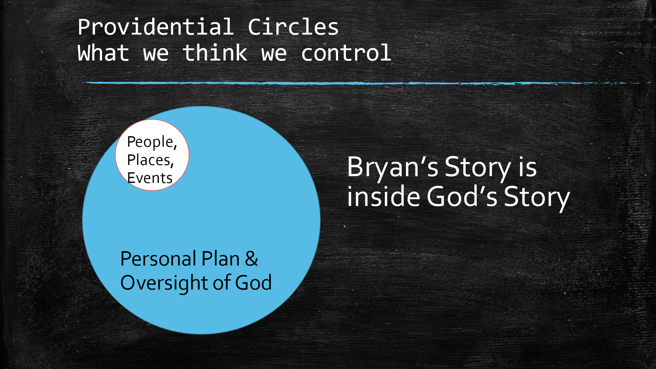
Bryan’s Story (1) Be involved in the church. God absolutely works through His church. (2) Be open to respond to that "Hey Bryan" moment ... you never know what God has in store! (3) Be open to initiating that "Hey Bryan" moment ... you never know what God has in store! (4) Look for opportunities to lift one another up with jobs or other lifetime helps. This is a significant way we honor our Lord and bear one another's burdens. (5) Keep praying ... even if it takes 9-1/2 years to hear back from God.
Nothing Has Changed Since Genesis
- How do we speak to communicate that God continues to work on our behalf?
- How do words like “providence,” “beneficence,” “immanence,” or “common grace” impact work?
- How should we treat people as “people” at work instead of “resources?”
- How should we treat problems as “problems” to be overcome instead of placing blame?
- Why should the “bottom line” of profit include the “bottom line” of people?

