Why the University Should Matter to the Church
Episode #3: What Does It Matter? The Significance of ‘Meaning’
Biblical | Theological | Historical | Philosophical | Practical | Example

Examples Student Q, “What is the purpose of life?” Faculty comment “Something was still missing.” Psychology classes include data but not human Qs. Escher staircases to nowhere. About Schmidt movie. “Life of a child” quote. Metallica, “Nothing Else Matters.” Poetry: e. e. cummings “Manunkind,” Poe, “The Conqueror Worm,” Shakespeare, “Hamlet” (Act 5 Scene 5). Simon Sinek 2009 Ted Talk. The three questions that always need to be answered: “So what?! Who cares?! Why should I listen to you today?!” Shinedown “A Symptom of Being Human”
What does ‘meaning’ mean? Significance, worth, purpose, reason. Qs to consider: (1) What matters? (2) Where do I look? (3) Does my life count? (4) Who decides? (5) What now?
What makes life meaningful in university? Why “Why?” is the most important question in life. (Hint: And the answer is not, “To get good grades to go to a good college to get a good job to make good money to have a good life.”). University is where: Indicative: forming beliefs. Imperative: making choices. Intention: life planning. Importance: students deciding. Instruction: profs teaching. Not “checking boxes”
Stealing Moses “When your children ask you ‘Why?’ you are to say” (Ex 12, Deut 4, 6, 11, Josh 4). Joshua 4:1-9: 4:6 “sign” historical marker, pointing back to an event; a “billboard;” 4:7 “memorial” planned reflection for generations to come; Pay attention: planned [curricula], action based; audible; physical; Q/A, Stories, Visual Aids; Church “memorials” Why ‘Why?’ matters: Joshua 4:24
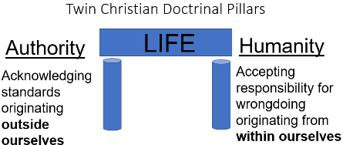
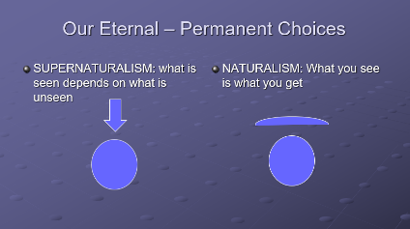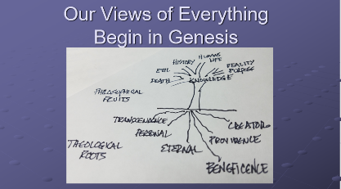
Crowned with Glory and Majesty ‘Crown’ suggests a wreath, woven with flowers, worn at banquets as a sign of royal authority—honored and elevated. The exaltation of humans by Yahweh begins as an inward essence; humans bear the weight (“glory”) of God, a show of uniqueness. Human significance begins with the character of Yahweh; a person’s worth, value, and dignity has intrinsic beginnings. “Majesty” is more of an extrinsic display of God—what is put on public display. Having a good reputation “in the sight of God and man” (Luke 2:52; 2 Cor 8:21) demonstrates the inside-out, character-conduct key to Psalm 8:5. “Glory” = wealth: The more one "tipped the scales" with gold, for instance, meant the person's wealth showed their "glory.”
Thomas Aquinas What matters? Where do I look? Does my life count? Who decides? What now? Summa Theologica Ultimate purpose is to know God, to glorify Him forever. Westminster Catechism “What is the chief end of man? To glorify God & enjoy Him forever.” [1 Chr 29:11-12; Ps 16:11; 43:3-4]
Further notes on “Glory” and “Meaning” - Why did God create us? (for His glory is 43.7) Did God need humanity? (aseity, Acts 17.24-28) Do humans create their destiny? (for God’s good pleasure Eph 1.11) Purpose? (glorify God 1 Co 10.31) Purposeless = time + chance + impersonal force // Purposefulness = plan + power + Personal God. Ecclesiastes = life has meaning, “All of life is a gift from God” (2:24, 25; 3:12, 13; 5:18-20; 7:14; 8:15; 9:7). Everyone says, “I want my life to count for something.” Acts 13:36 “David, after he had served the purpose of God in his own generation, died.”

