Why the University Should Matter to the Church - Episode #1 “Why Do I Have to Learn This?!”
Biblical | Theological | Historical | Philosophical | Practical | Example

“Why do I have to learn this?!” 12 biblical responses (on back)

University = “uni” (one) “versity” (many) “How do the one and the many fit together?” Philosophers: the last, most important question to ask was “How does life work so it’s not chaotic?”

Coherence Creation makes sense because of The Creator: Genesis 1.1 Truth Needs Coherence
“The heavens and the earth,” in the Hebrew mind, included everything from A to Z. The Hebraic-Christian worldview has a coherent, cohesive overarching, creational, sustaining order. Everything “fits together.” “In Him all things hold together” (Col 1.17)

Trinity “Three persons in one essence” God created the cosmos to mirror His nature. In this way, education “fits together” There is a cohesive system through which to understand the world. Today’s schools owe their origin to this Christian viewpoint promoted by educational reformers.

John Amos Comenius Father of Modern Education Comenius promoted encyclopedic knowledge.
“pansophy”—wisdom gained throughout the world. Comenius practiced synthesis: the intersection and unification of all things. All great universities seek the same thing—the harmony of all knowledge. Influence on Harvard Harvard’s crest includes three books: the book of God’s Word, the book of God’s world, and the book of logic. Overlaid on these books is the word veritas, Latin for “truth.”

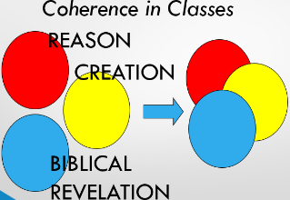
Educators all disciplines, levels (K-12 – PhD) depend on coherence. Comenius influenced the foundations of modern education. Science: Discoveries are verifiable by researchers around the world. What is true in one place is true in another. Consciously or unconsciously all people are taking note of God's interaction in the world (Job 37:7, 14; Ps 64:9 "All mankind will ponder what He has done"; 65:8; 66:5).

Coherence Common Truth Believers & unbelievers declared The Hebrew God created & unified all things; Rahab, Hezekiah, Hiram, king of Tyre. Prophets throughout Scripture declare—all things come from & are held together by Yahweh (Josh 2.11, 2 Kgs 19.15, 2 Chron 2.12 Neh 9.6, Prov 30.4, Isa 44.24)

Coherent Christian in University Theological – Philosophical Christian Truths: (1) “In Christ are hidden all the treasures of wisdom and knowledge” Col 2:3 (2) There are no brute facts (3) Equality of beliefs is impossible (4) Neutrality is a myth (5) Everyone’s assumptions frame their view of knowledge How to live in the university: 2 Tim 2:24-25; 1 Pet 3:15-16 kind gentle respectful patient not quarrelsome

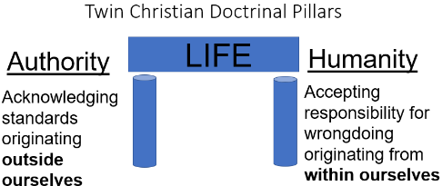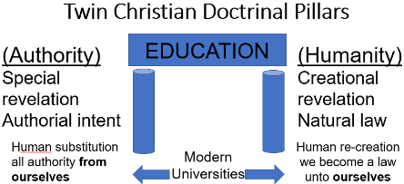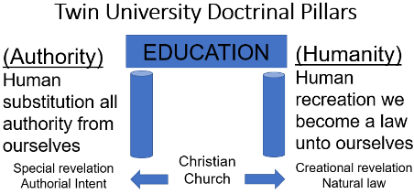

Coherence University Questions How can The Church better support its young people who are attending university? How should I respect scholars who have added to human knowledge, no matter their beliefs? How does special and creational revelation help me know how to interpret information? How do I show respect at the same time not conforming to a college professor’s views? [“Don’t believe anything…”] When I read, listen to, or watch anything do I think with a coherent Christian view?
Why Do We Have to Learn This?! Stewardship of resources—we are responsible to protect and produce from what we have been given in life—is humanity’s first command (Gen 1:28). Ultimately, our growth in Christ—our sanctification—is an understanding of all things from His perspective. To answer the question above I would ask, “Are we interested in our own personal sanctification in Christ?”

- If this is God’s world, He made it, and it is important to Him, it should be important to us (Gen 1; 1 Chr 29:11; Neh 9:6; Ps 33:6-11; 50:9-12; 89:11).

- If the creation praises God for His works, then we praise God for His creation (Ps 19; 104; 148).

- We honor, magnify, and glorify God for Who He is—Creator of all (Ecc 12:1; Isa 40:26; 42:5; 44:24; 45:7; 45:18; Amos 4:13; John 1:3; Acts 7:5; Rom 1:25; 1 Cor 8:6; Eph 3:9; 1 Pe 4:19).

- If all knowledge comes from Jesus, then we are responsible for that knowledge (Col 2:2-3; 1:9; 2:4, 8).

- We are responsible to grow in the knowledge of Jesus (Eph 1:15-23; Phil 1:9-11; Col 1:9-10).

- We are responsible to develop biblical, critical thinking skills (Prov 2:1-6; Col 2:8; Heb 5:11-14). Wisdom is how we better understand the world (Proverbs 8).

- As creatures responsible to The Creator, we have been given responsibilities to rule the creation (Gen 1:28; 2:5, 15, 19-20; Ps 8:5-8).

- God has created the earth for human benefit (Ps 115:16; Is 45:12).

- Even unbelievers ponder what God has done in His creation (Ps 64:9; 65:8; 66:4; 67:2, 7) which should be the believers’ response (Ps 111:2).

- We should thank God for the various gifts given to people, whatever they are, and however they may benefit others (Rom 12; 1 Cor 12; Eph 4:11-12; 1 Peter 4:10-11).

- We give God glory in everyday living about everything (Ps 115:1; 1 Cor 10:31; Col 3:23).

- Satisfaction, Appreciation, and Thankfulness is the most important SAT test we will ever take (Deut 8:10-20). To be ungrateful for the gifts given to us, is to reject The One Who has given those gifts to us (Rom 1:21). We ought to give thanks for all things (Eph 5:20; 1 Th 5:18) since He has given everything for us to enjoy (1 Tim 6:17).

Coherence Questions: Do we teach facts or do we teach facts in relationship to our students, ourselves, and “the heavens and the earth?” / Do we ask, “Why does the wind blow?” (air is moving from a warmer to a cooler place) and “What does it mean that the wind blows?” (parts of God’s world work together). /
Do we believe that all of life is interrelated and then give “pat answers” to our students’ questions about “the heavens and the earth?” / When we speak of “integrity” do we understand and teach its connection with “integer,” “integral,” “integration,” and “intelligence” (comprehension of the whole)? / How often do we use the following words in our teaching and how do these words provide “pointers” toward the God who made “the heavens and earth?” Laws or rules. Observation. Prediction. Steps or sequence. Possibility. Direction. Properties. / Do we think about an inter-disciplinary approach to teaching so that our students see the intersection and unification of “the heavens and the earth?” / Do we consider all parts of our lives are interwoven in the fabric of “the heavens and the earth” for all people places time cultures?

